|  |  |  |
| --- | --- | --- |
| CONNOPS | February 16  2016 | |
| Making Facility Management more intelligent and efficient. | | Systems Requirements Review |

|  |  |  |  |
| --- | --- | --- | --- |
| **Revision record** | | | |
| Version | Date | Attendees | Comment |
| 1.0.0 | 16.02.16 | Arshad Shakil,  Badis Madani,  [Håkon Hedlund](https://www.facebook.com/hakon.hedlund)**,**  Zhili Shao |  |

Contents

1. Goals and objectives of the system 2

2. Boundaries of the system 2

2.1. Internal interfaces of the system 3

3. Stakeholders 4

3.1. Interaction between stakeholders 4

4. Constraints that affect system or that influence it 5

5. Conceptual view of the system 5

6. Processes involved in fielding, commissioning, using, maintaining and retiring the system 6

# Goals and objectives of the system

Goal of the smart HVAC control system is to make user change their indoor environment easily and help maintainers manage the HVAC system efficiently.

System has to give users more easy ways to configure their environment, and also it should be smart enough to keep a comfortable environment for users according to some factors like weathers, time and so on. Also it should provide some useful references when some wrong happen with HVAC system. (Multiple facilities can be monitored from one centralized facility.) ARSHAD

# Boundaries of the system

From physical point of view, boundary of the system is that it will be used inside of the establishments that has it implemented.

From economical perspective, boundary would be CAPEX (Capital Expense) budget defined for certain period of time.

Also, we have to consider realization boundaries, which would include traditional or modern age technical solutions that are currently available.

NEEDS TO WRITE IT IN ANOTHER WAY

As for interfaces, the data pulled from the internet would be an external interface. Also the data generated in the cloud to be sent to the heating system would also be an external interface. ARSHAD

# Stakeholders and their requirements

## Stakeholders:

* Users – individual who visit, work, study in the building;
* Facility manager – people who work for building maintenance;
* HVAC vendor – company provide HVAC equipment or solutions;
* Tenants – people/organizations who live/rent premises in the building;
* Estate owner – people/organizations who own the building.
* Government- organization standardize regulations about environment and energy

## Stakeholder’s requirements:

Users:

A comfortable customized indoor environment (high level).

1. Set temperature, humidity, indoor air quality to certain value;

2. Turn on/off system according to the time;

3. Load configuration data created according to daily weather and outside temperature.

## Facility manager:

1. Energy saving (motion sensor…);

2. Easy and fast troubleshooting (diagnosis report);

3. Easy maintain (self-inspection report, everyday operation log).

## HVAC vendor:

1. Easy deployment;

2. Compatible with their equipment;

## Tenants:

1. Low cost;

2. Stable HVAC service;

3. Less influence on their main business.

## Estate owner:

1. Low energy cost;

2. Long life;

3. Low update cost.

## Government

1. Regulations has to be met

# Constraints that affect system or that influence it

Size of the building, time of the day, weather, characteristics of the building (isolation, energy saving building, smart building), function of the building (restaurant, factories, hospitals etc) ARSHAD

# Conceptual view of the system

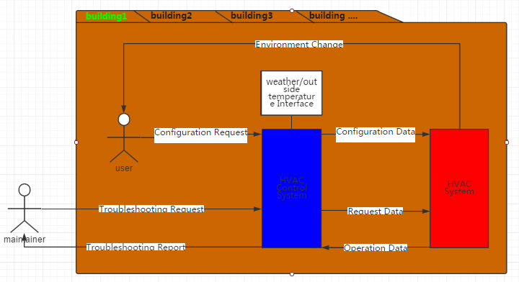

# Processes involved in fielding, commissioning, using, maintaining and retiring the system

BADIS WILL MAKE IT